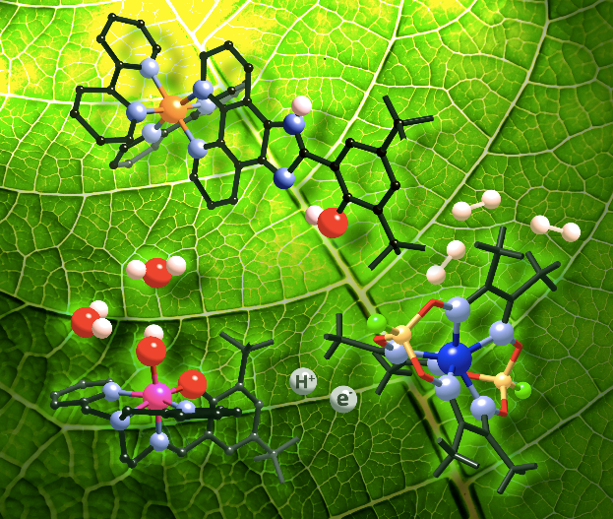
© Ally Aukauloo (Université Paris-Saclay)

IBIS Contest
APPLICATION FILE

- Project title (and acronym)
- Summary (200 characters maximum)

For the main leader:
- NAME:
- First name:
- Institution:
- Curriculum and level of education:
- Phone:
- Mail:
- Referent Teacher or Researcher (Name, First name, function, mail).

Other project leaders:
- NAME:
- First name:
- Institution:
- Curriculum and level of education:

Detailed description of the project in English or French (5 pages maximum) shall especially address the following items: context, issues, proposed solution, potential applications, technology readiness, possible results already achieved and expected achievements.

Optional appendix: supporting documents for understanding and/or consolidating the project.

Applications must be emailed to
association@iledescience.org

Deadline for receiving applications: Mai 31, 2021 (midnight)

WITH THE SPONSORSHIP OF
